|  |  |
| --- | --- |
| CSU_Logo Mark_CMYK.jpg | ITC539 Mobile Application Development  2015  **Assessment 3 cover sheet** |

Student Name: Elizabeth H Burgess Student number: 11571039

**PLEASE RETAIN A COPY OF THIS SUBMISSION**

DECLARATION

I certify that:

1) This assessment is my own original work and represents my intellectual property and that the material presented in this assessment, which is not otherwise acknowledged, is my own work.

2) This assessment has not been submitted before by me or anyone else in this or any other subject at a tertiary level for assessment.

3) I have read and understand the CSU Student Academic Misconduct Rule and associated penalties for academic misconduct.

4) I have retained a copy of this assessment.

**Name:** E. H. Burgess

**Date:** 20/08/15

**Project Proposal**

**Total Marks:**20

In this assessment task you need to develop a detailed project proposal based on the project title proposed in assessment item 1. You are required to choose/plan a mobile application development plan and propose project execution plan. The report may include the following information, but the report may not be limited to only following information. You may think of any other relevant and important information relevant to your project that may become part of your report.

**Note:** You are required to develop a document (MS Word or PDF) for this assessment submission. There is no page limit or word limit for this assessment; however, your document must not be overly length and must not be very brief. The document must contain the assessment requirements given in the task and in the marking guide. Use proper APA style referencing wherever required.

1. **Introduction**

The Mobile application I propose is The Digital Vehicle Expenses Log or The D.V.E.L. This application is for the recording of all business and vehicle expenses during a financial year for taxation / business purposes.

The information that will be recorded:

* Multiple vehicles and their insurance details
* FBT year dates
* Taxation year
  + Calculates and creates reports for percentage of business use
  + Logbook period –minimum of 12 weeks recording
* Initial Odometer reading
* Easy selection of journey purpose
* Calculate your trip data from odometer readings at start and end of trip if manual entry
* Optional use of GPS to automatically calculate to calculate end odometer value and record start/end locations as well as route information. (Phase 2 implementation)
* Editing of existing trip records if some details are wrong.
* Calendar & contact entries selection for purpose of journey
* Records expenses such as fuel, insurance payments, repairs - capture invoice / receipt via camera
* Publishes both CSV and PDF copies of your expenses logbook that can be either saved to your cloud storage, or emailed to your accountant or tax agent.

As this application is recording information that will be used for taxation purposes it is important that the application be ATO compliant

1. **Development Platform and Programming Language**

The platform for the development of this application is Android 5 (Lollipop) using C# and Xamarin.

The reasoning behind choosing the Android platform is:

* According to research has a larger market share through the diversity of hardware manufacturers. According to TomiAhonen Consulting’s Analysis - Installed based of Smartphones by Operating System as of 30 June 2015 Android is installed on 76% of smartphones (Ahonen, 2015). Table 1 below shows the statistics in detail.

|  |  |  |  |  |  |
| --- | --- | --- | --- | --- | --- |
| Rank | OS Platform | Units | Market share | Was Q1 | Main Manufacturers of current base |
| 1 | Android | **1,730 M** | **76 %** | (75 %) | Samsung, Huawei, Sony, ZTE, LG, Lenovo/Motorola, Xiaomi, Coolpad, TCL-Alcatel |
| 2 | iOS | **449 M** | **20 %** | (20 %) | Apple |
| 3 | Windows Phone | **46 M** | **2 %** | (2 %) | Microsoft (Nokia), Samsung, HTC |
| 4 | Blackberry | **24 M** | **1 %** | (1 %) | Blackberry |
|  | Others | **30 M** | **1 %** |  |  |
| TOTAL Installed Base **2,284 M** smartphones in use at end of Q2, 2015 | | | | | |

Table 1: INSTALLED BASE OF SMARTPHONES BY OPERATING SYSTEM AS OF 30 JUNE 2015 (Ahonen, 2015)

* Initially the application was going to be built for Windows Phone. This will not happen at the moment as Microsoft’s market share in the smartphone arena is dwindling and may disappear completely. In the future this application may be created as a Universal application to be used on tablets and notebooks.
* By building the application in Xamarin and C# porting the code over to iOS and Windows in the future is able to be done without having to refactor for a different programming language i.e. Java to Objective C or Java to C#, saving both time and money.

1. **Device Capability Requirement**

The Device envisioned for this application has the following capabilities:

* GPS location data
* Access to API provided by third party
* Access to cloud services like Google Drive to store reports via data access
* Data access to send report via email
* Calendar & contacts access
* Touch screen

1. **Use Case (UML) and Class Diagram (5 Marks)**

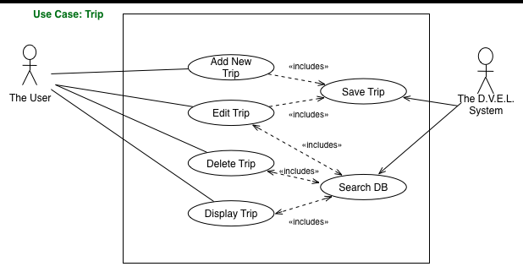

Figure 1: Trip TAB Use Case Diagram

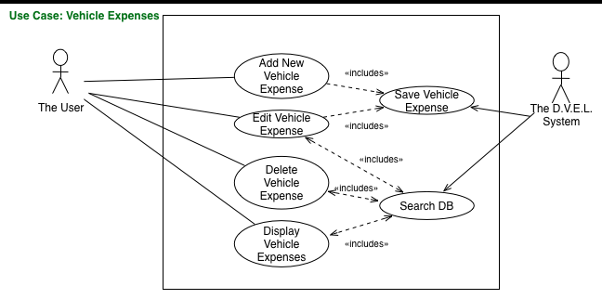

Figure 2: Vehicle Expenses TAB Use Case Diagram

**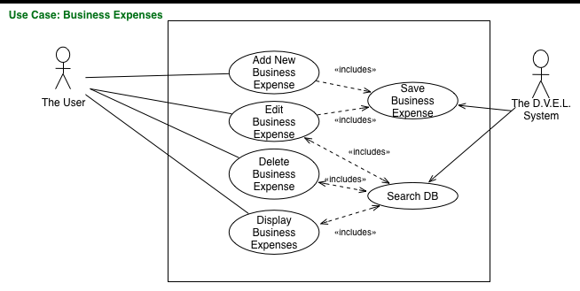**

Figure 3: Business Expenses TAB Use Case Diagram

**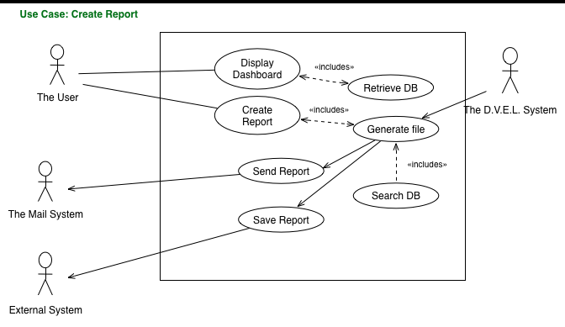**

Figure 4: Create Report Use Case

**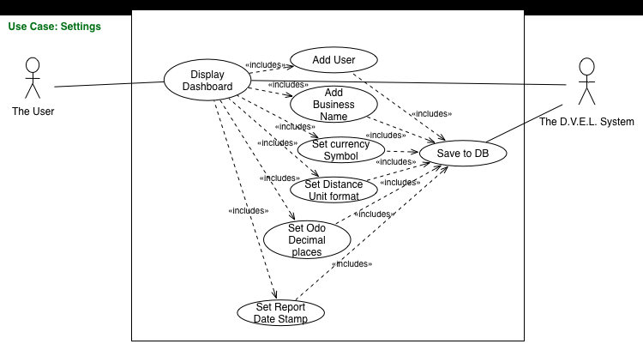**

Figure 5:Settings Use Case

**Class Diagram**

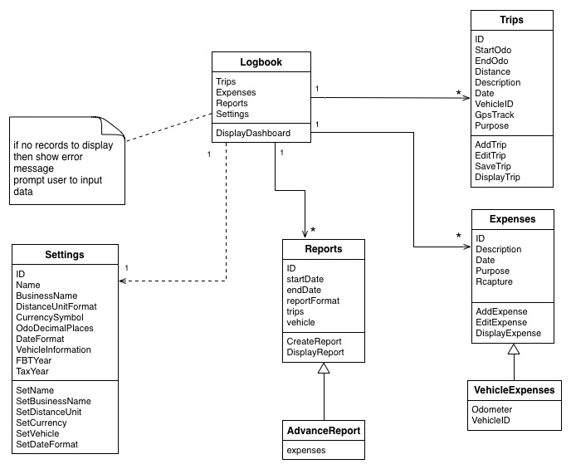

Figure 6: Class Diagram for The D.V.E.L.

1. **User Interface and Interaction (3 Marks)**

The following set of diagrams provides the Interaction design and user interface. The information on the interface has been guided from the Wildon Vehicle & Business Expenses Log book as well as looking at existing vehicle logbook applications on the Google Play Store.

There are four sections buttons on the front screen that give a clear indication through iconography and wording of their purpose. Each section has a landing screen that provides a small history of transactions that have been done.

To put all the transaction in a similar area like in the physical logbook the user can swipe to the various historical screens.

I have provided more than one way to get to the various parts of each section with the Business Log providing a shortcut to the Business Expenses screen.

The screens have been kept consistent so that when a user inputs data the screen is already familiar to them for saving or cancelling the input. Visual clues for editing and deleting records have also been put in the design to make it more intuitive.

The application also adheres to Google Material Design guidelines in regards to icons, images etc.

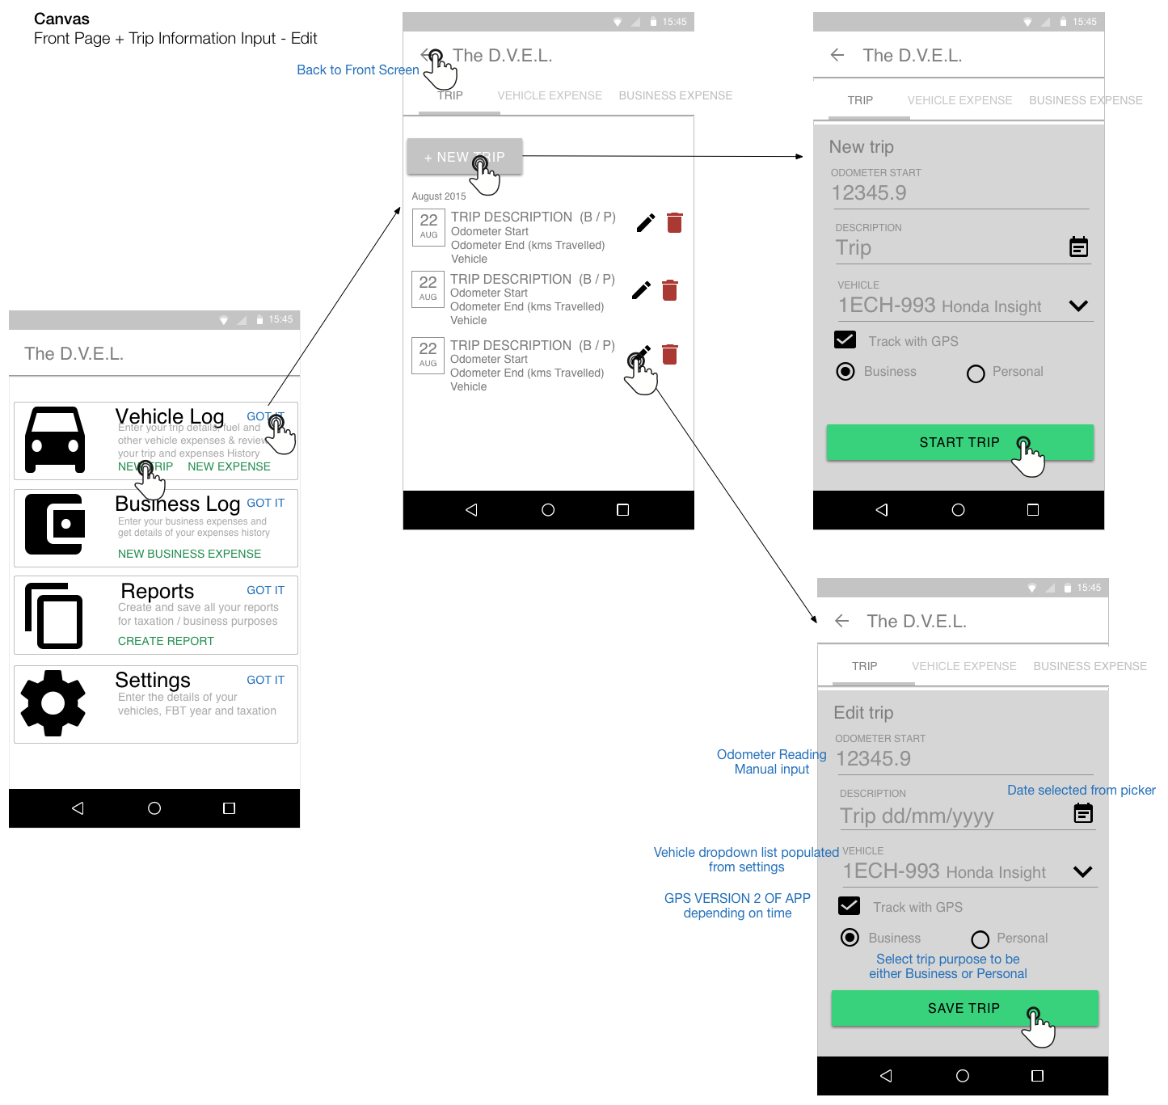

Figure 7: Front page & Trip information interface Interaction

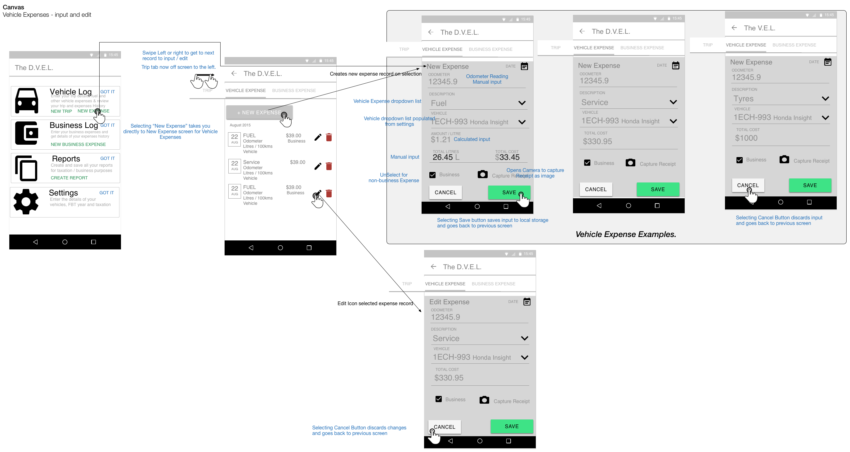

Figure 8: Vehicle Expenses interface Interaction

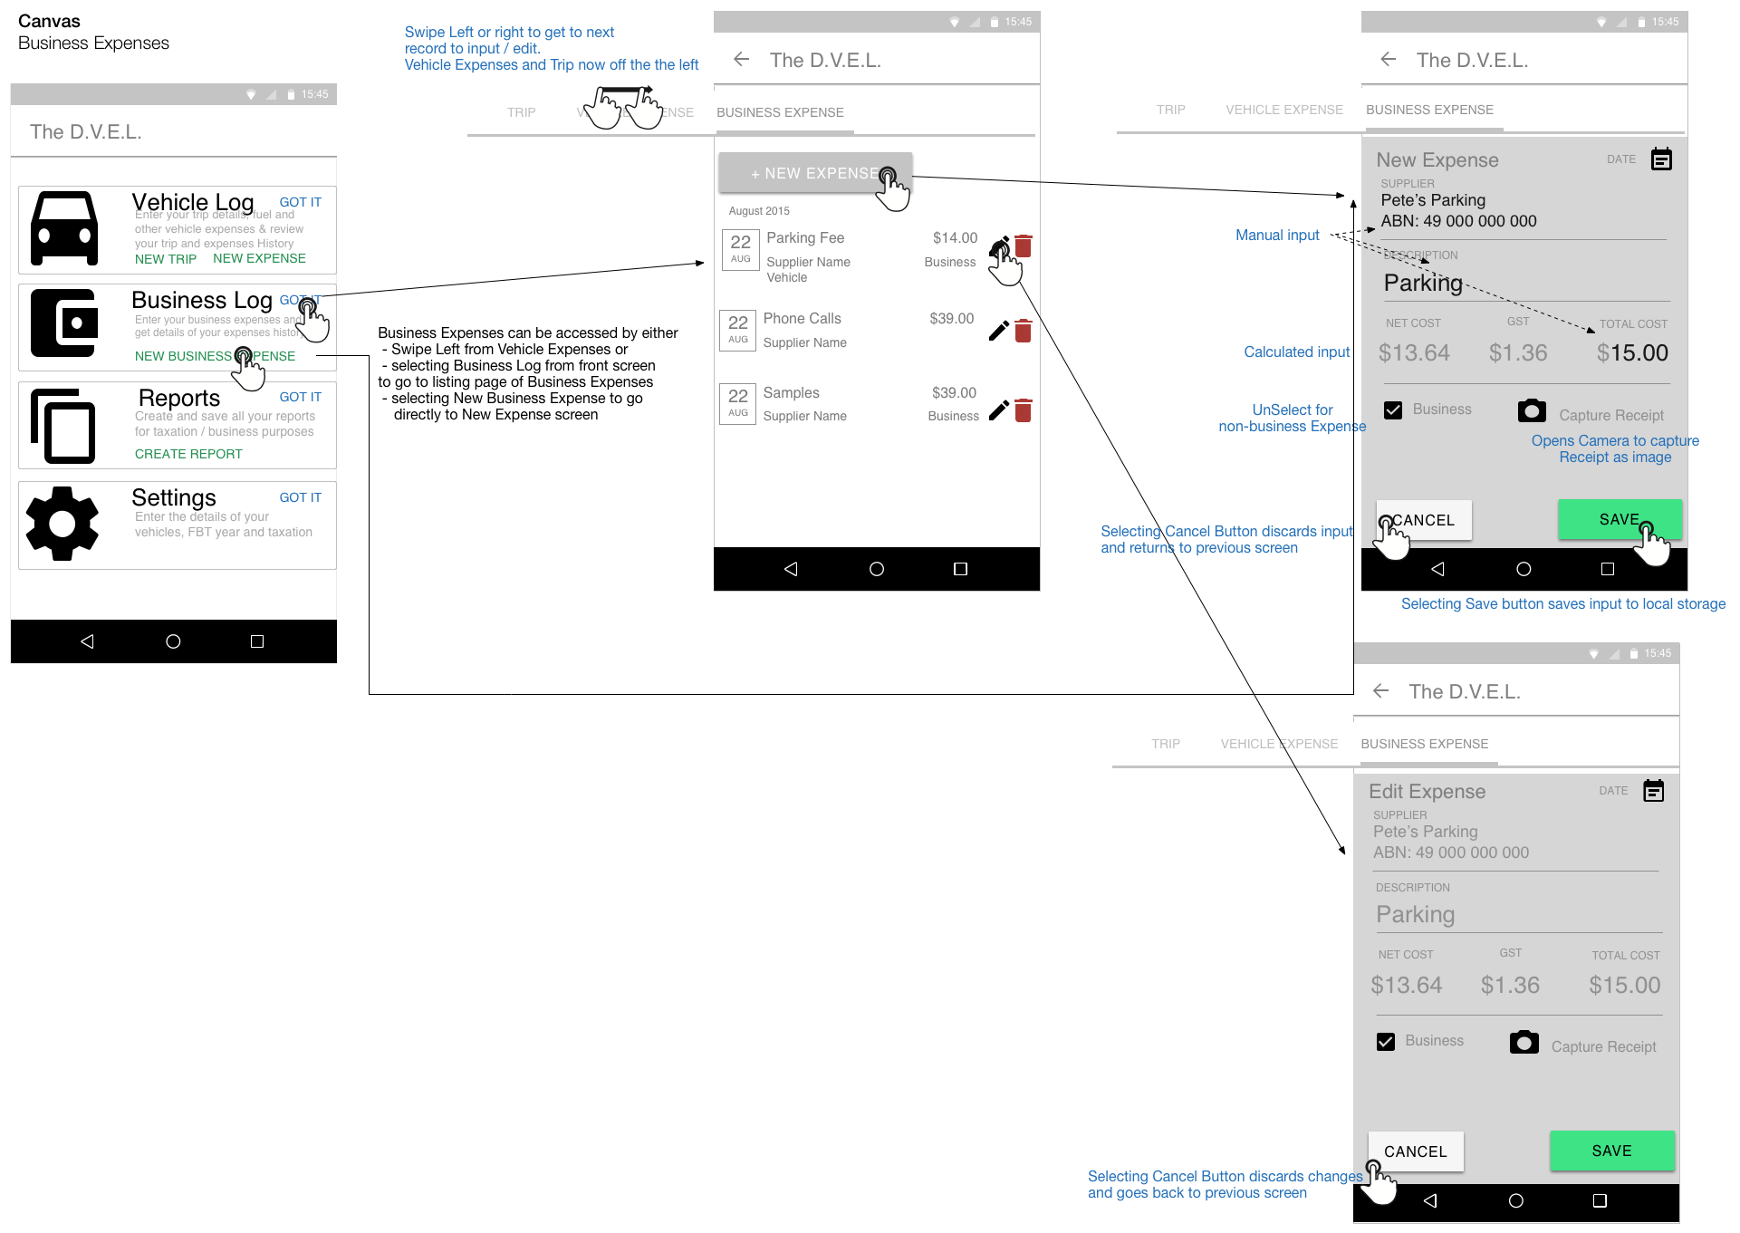

Figure 9 Business Expenses interface Interaction

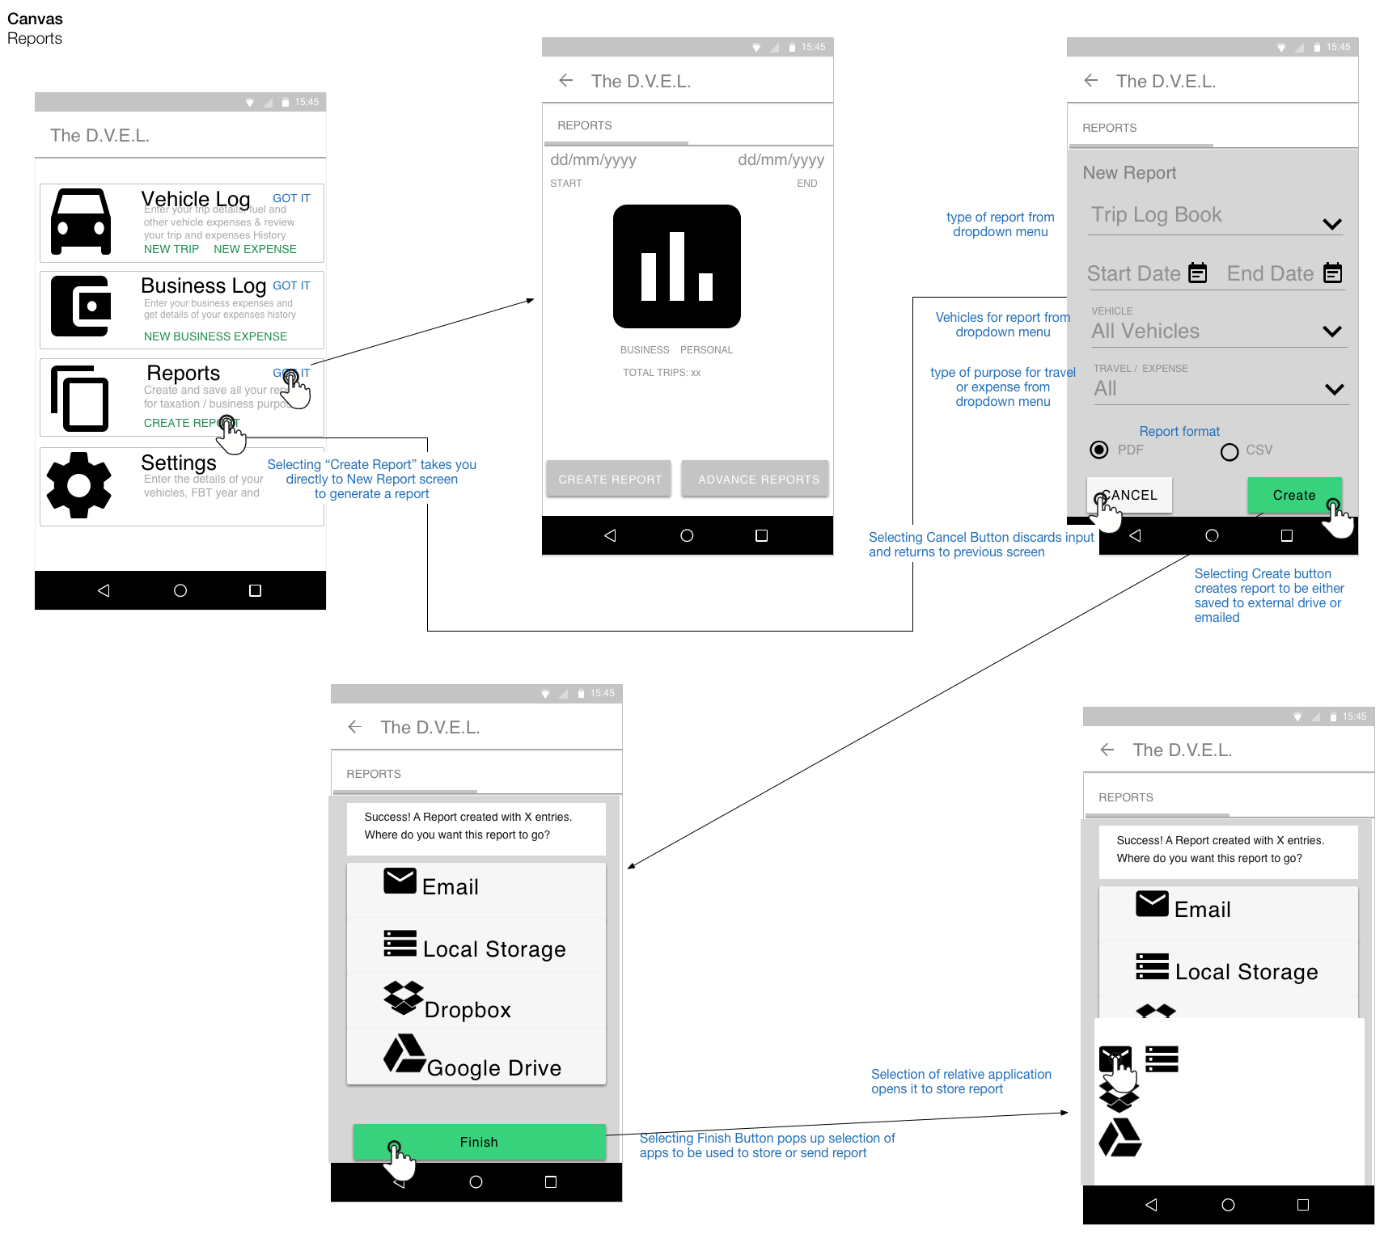

Figure 10: Reports Interface Interaction

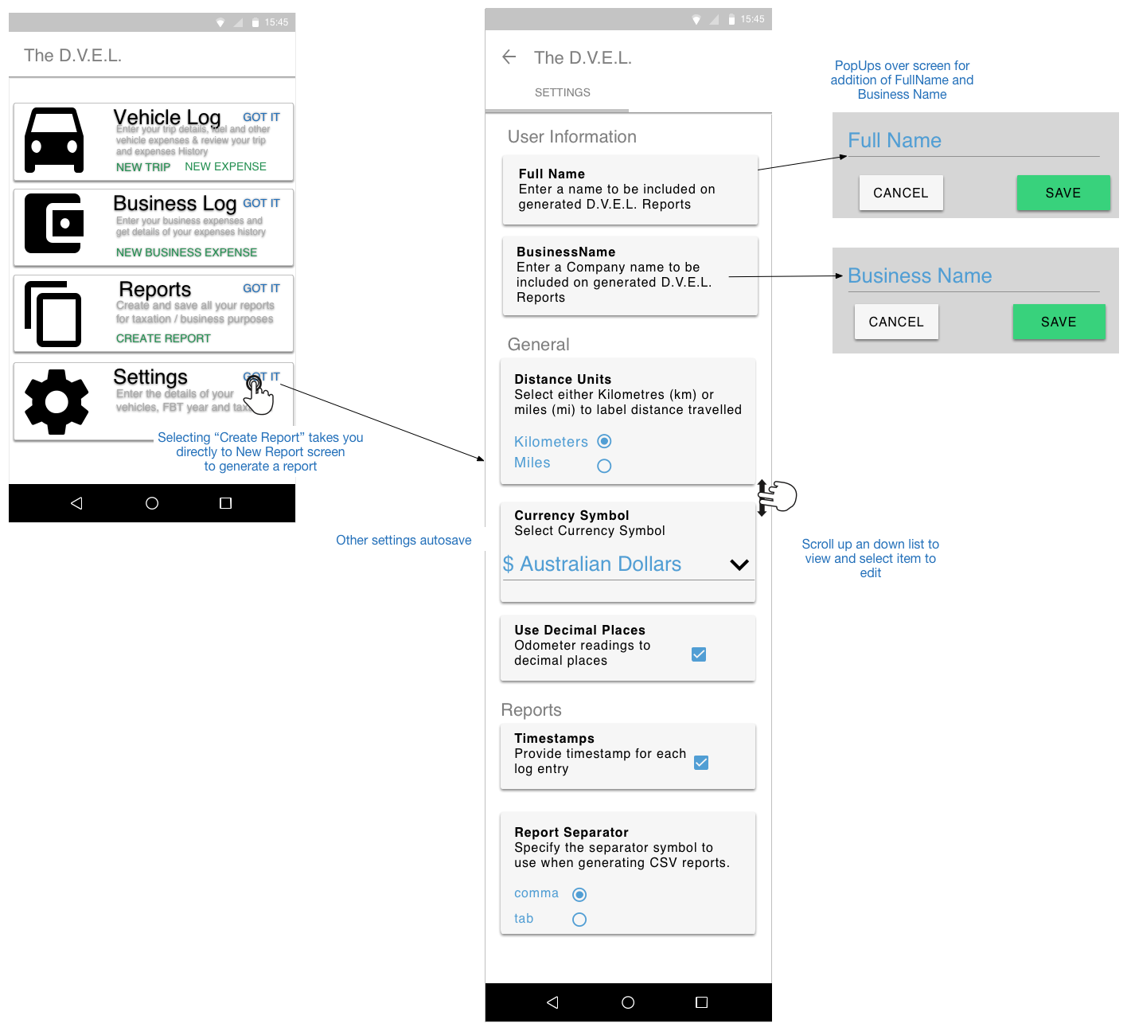

Figure 11: Setting interface Interaction

# Bibliography

Ahonen, T. T. (2015, August 10). *Smartphone Wars Q2 Scorecard*. Retrieved August 14, 2015 from Communities Dominate Brands, Business and Marketing Challenges for the 21st Century: http://communities-dominate.blogs.com/brands/2015/08/smartphone-wars-q2-scorecard.html

Freepik. (2015, 1 1). *http://www.flaticon.com/free-icon/dropbox-logo-black-silhouette\_37246*. Retrieved 8 17, 2015 from Flaticon: http://www.flaticon.com

Freepik. (2015, 1 1). *http://www.flaticon.com/free-icon/google-drive-logo-symbol\_24266*. Retrieved 8 17, 2015 from FlatIcon: http://www.flaticon.com